Lesson 6 E&C WATCH OUT FOR WATER | 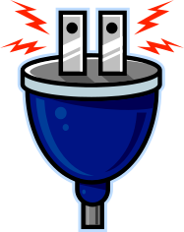

AIM OF THE LESSON

During this lesson students will:
- Investigate how much salt is needed in water to make a globe light up.
- Discuss the safe use of electrical items at home.


EQUIPMENT

Per Class
- masking tape

Per Group
- glass jar
- table salt
- 2 D batteries (1.5V)
- 3 x 15cm lengths of plastic coated copper wire
- plastic spoon
- alfoil
- 2 pop sticks
- 1 globe

Preparation
  - Enlarge the placemat handout onto A3 paper.

Safety
- Mains electricity must not be used.


Background Information for teachers

Water and Electricity
- Your body is 70% water. Water is an excellent conductor so you are a very good conductor of electricity.
- You can become electricity’s path to the ground if you are touching water that touches electricity. Electricity would travel through the water, through you, to the ground. When a source of electricity has higher voltage than your D-cell batteries, the electricity will travel through water with or without salt in it. So, if lightning struck a lake, or a blow dryer fell in the sink, electricity would travel through the water. Anyone touching that water could be electrocuted.
- Electrocution means fatal contact with electricity.
- It is vital to keep all electrical appliances away from water, and to make sure your hands are dry and you are not standing in water when you touch anything electrical. Water should never be used on an electrical fire. A fire extinguisher should be used instead.
Safety Check in the Home
- Electric outlets are not overloaded with lots of plugs.
- Electric cords are in good condition.
- Electric cords do not run under rugs or furniture legs or near hot appliances.
- Electric appliances are used away from water.
- People carry appliances by the handle, not the cord.
- A multi purpose fire extinguisher is kept in the house.
- All danger and warning signs are read and carefully followed.
- Electric appliances that can get hot - such as heaters, toasters and light bulbs - are kept away from things that can burn.
- Safety caps are inserted in outlets when small children are around.
- Small appliances are turned off and/or unplugged when people leave home.
- Do not touch anything electrical while you are wet or standing in or near water.
- Do not fly kites, model airplanes or balloons near power lines.
- If you ever find that a power line has fallen stay away from it and report it immediately to an adult.
- Stay away from anything marked "Danger", "High Voltage" or "Keep Out".


Lesson Outline

1. Introduction (Engaging Students)
- In groups of four, students complete the placemat sheet of some of the dangers at home with electricity. Each student is to complete one of the triangles and then share within their group to put some common ones in the centre circle. These could be shared with the class.

What is a key danger with electricity?  Why is water and electricity a problem when mixed?  What are the places where this could be a danger?  How is it possible to have lights in a swimming pool? | Water  Water is a good conductor of electricity and can cause electrocution (death from electricity)  Bathroom, kitchen, swimming pool washing machine, dishwasher.  The lights are water proof, insulated and earthed.

2. Activities and Strategies
- This activity demonstrates how water conducts electricity.
- See handout for diagram.

- Twist alfoil around one end of two copper leads.
- Set up a circuit using two batteries, a globe and three bits of copper wire.
- Check that the circuit works.
- Place the two alfoil ends in the jar and touch them together to make sure
the globe lights up.
- Separate the two alfoil strips with pop sticks so they are not touching.
- Two thirds fill the jar with water so that the alfoil is covered with water.
- Observe if the globe lights up.
- Add one spoon of salt and observe the globe. Repeat this six times and
observe any differences in the globe.
3. Focus Questions (Explain and Elaborate)

Did the globe light with the pure water?  Why was the salt added?  What happened when you added more salt?  Why does a bath of water conduct electricity so well?  Is lightning and water dangerous together? | No.  To make the water a better conductor.  The globe became brighter.  The electricity from a power point is more powerful (240 volts) while from a battery it is much weaker. (only 1.5 volts). This means mixing water and mains power is extremely dangerous.  Yes, very dangerous as lightning is even more powerful than mains electricity.

4. Reflection
- Write a conclusion to the activity.
- Write down five safety rules when using electricity at home.


Extension Activities

  - Replace the water with other liquids such as vinegar, milk, lemon juice, oil or soft drink to find out if they conduct electricity.
  - Replace the salt with other solids such as sugar or baking soda to see if they conduct electricity.


Links to other learning Areas

- Create a television or radio announcement that warns people about electrical hazards.
- Write and carry out a survey in your home to determine how safely electricity is used.
- Prepare a poster warning of the hazards of electricity and water.
- Write a list of rules to follow when using electricity in the classroom.
- Find a newspaper article on an electrical safety issue and write a paragraph to summarise what it is about.
- Role-play a scene of an electrical accident.

ACTIVITY 6 WATCH OUT FOR WATER | 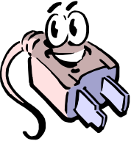
Aim (What are we going to find out?)

Equipment (What do I need to complete the task?)

Method (How is the task to be done?)

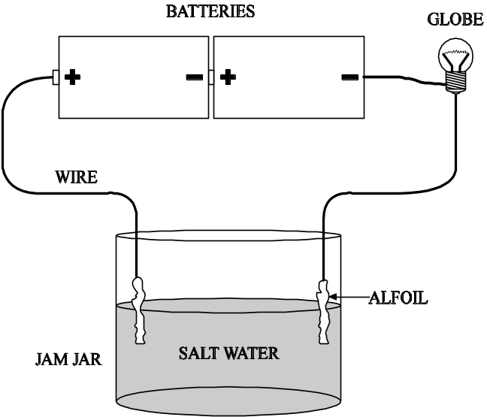

Results (What did I observe?)

Conclusion (What did I learn about water and electricity?)

Placemat
In groups each student writes down their ideas. Common ideas for the group are written in the centre.

